**Introduction:**

New England cuisine is an American cuisine which originated in the New England region of the United States, and traces its roots to English cuisine. It is characterized by extensive use of seafood and dairy products, which results from its historical reliance on its seaports and fishing industry, as well as extensive dairy farming in inland regions. Many of New England's earliest Puritan settlers were from eastern England, where baking foods was more common than frying, such as pies, beans, and turkey, as was the tradition elsewhere.

Two prominent characteristic foodstuffs native to New England are maple syrup and cranberries. The traditional standard starch is potato, though rice has a somewhat increased popularity in modern cooking. New England cuisine is known for limited use of spices aside from ground black pepper, although parsley, garlic, and sage are common, with a few Caribbean additions such as nutmeg. Use of cream is common, due to the reliance on dairy. The favored cooking techniques are stewing, steaming, and baking. Many local ingredients, such as squash, corn and local beans, sunflowers, wild turkey, maple syrup, cranberries and dishes such as cornbread, Johnnycakes and Indian pudding were adopted from Southern New England Algonquian cuisine.

So as part of this project, we will list and visualize all major counties in the Connecticut in United States and found out whether which county can be chosen to open an Indian Restaurant.

**Data Section :**

For this project we need the following data :

•         **Connecticut data that contains list of Zip codes for each county along with their latitude and longitude.**

*Data source :* <http://www.connquest.com/ct/zipcodes.html>

*Description : This data set contains the required information. And we will use this data set to explore various neighborhoods of Connecticut*

•         **Restaurants in each neighborhood of Connecticut.**

*Data source : Fousquare API*

*Description : By using this api we will get all the venues in each neighborhood. We can filter these venues to get only indian resturants.*

##### *Wikipedia - about the list of neighborhoods in Connecticut:*[*¶*](http://localhost:8888/notebooks/Downloads/Capstone%20Final%20CT.ipynb#Wikipedia---about-the-list-of-neighborhoods-in-Connecticut:)

[*https://www.zipcodestogo.com/Connecticut/*](https://www.zipcodestogo.com/Connecticut/)

[*https://www.unitedstateszipcodes.org/ct/*](https://www.unitedstateszipcodes.org/ct/)

*Open dataset to provide the latitude and longitude of the neighbourhoods in the Connecticut.*

*Foursquare API to collect information on other venues/competitors in the neighborhoods of Connecticut*

**Approach:**

* Collect the Connecticut data with county details
* Using Foursquare API we will find all venues for each neighborhood.
* Filter out all venues that don’t have Indian Restaurants.
* Find out the counties in Connecticut which don’t have Indian Restaurant using Foursquare API.
* List out the results and counties
* Visualize the neighborhoods using folium library(python)

**Questions that can be asked using the above mentioned datasets:**

•         What counties can be chosen to open a Indian restaurant in connecticut?

**Analysis**

So I did the analysis and got exciting results.

**Results**

1. We see that HartFord has the highest number of Neighborhoods.

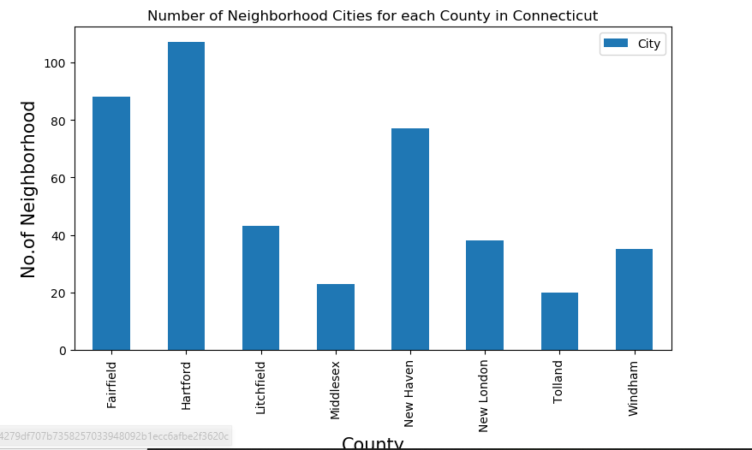

1. Also Fairfield county has the highest number of Indian Restaurants.

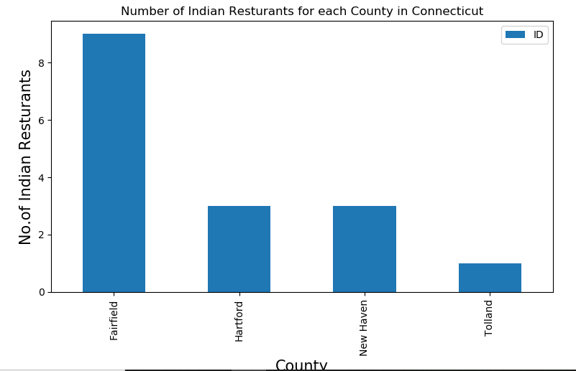

3. Stamford in Fairfield has the highest number of Indian Restaurants with a total count of 7.

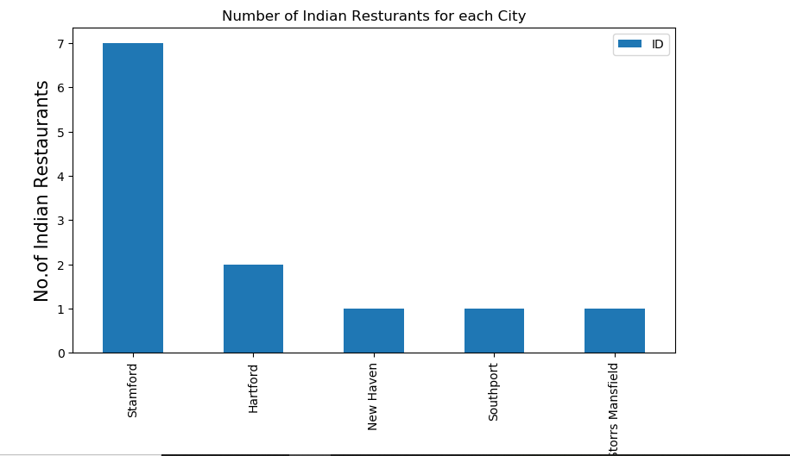

4. Fairfield has the highest average rating for Indian Restaurants.

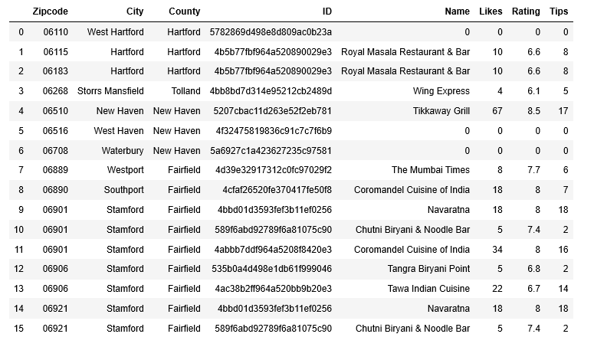

**Conclusion**

* Middlesex and Tolland counties are least in the Indian restaurant
* Fairfield and Hartford counties are the toppest among having the indian restaurant
* Tikkaway Grill and coromandel cuisine of india restaurants has the highest number of likes
* So Middlesex and Tolland counties are best to open a Indian cuisine restaurant

**Limitations**

•         The ranking is purely on basis of rating of restaurants

•         The accuracy of data depends purely depends on the data provided by Foursquare